1. 各种数据结构的优缺点对比（the advantages and disadvantages of the various data structures described in this book）  
   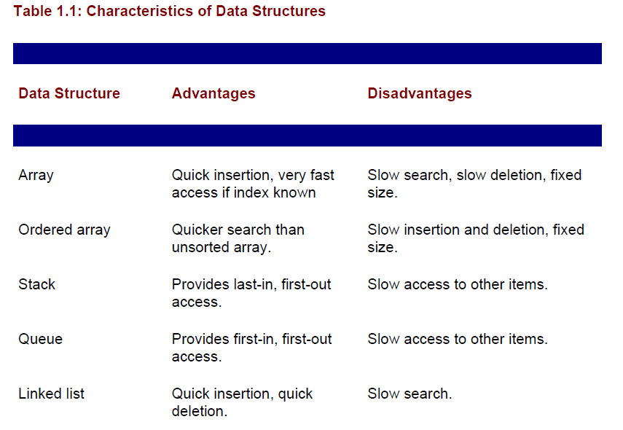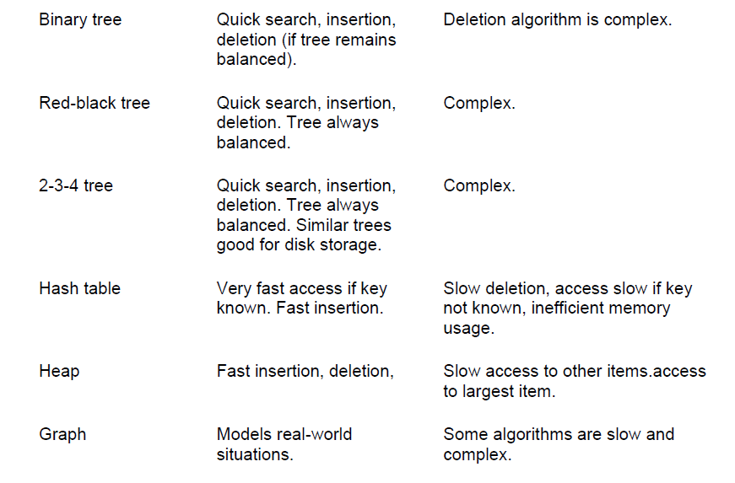
2. Definition  
   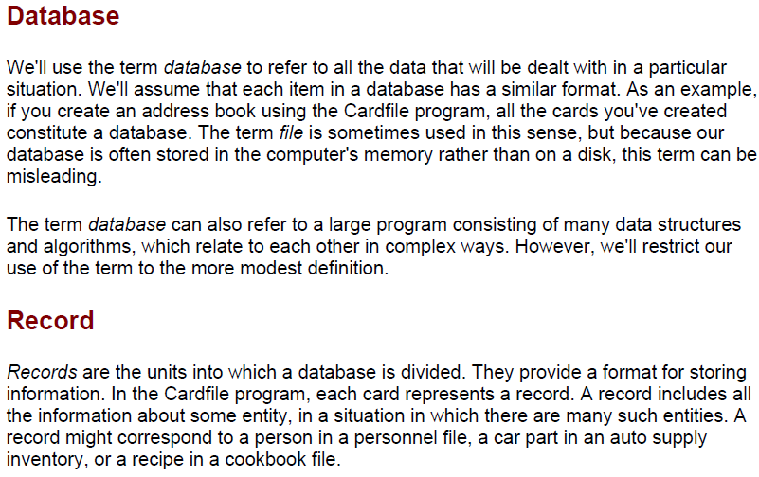  
   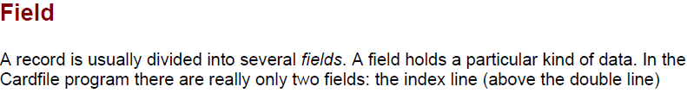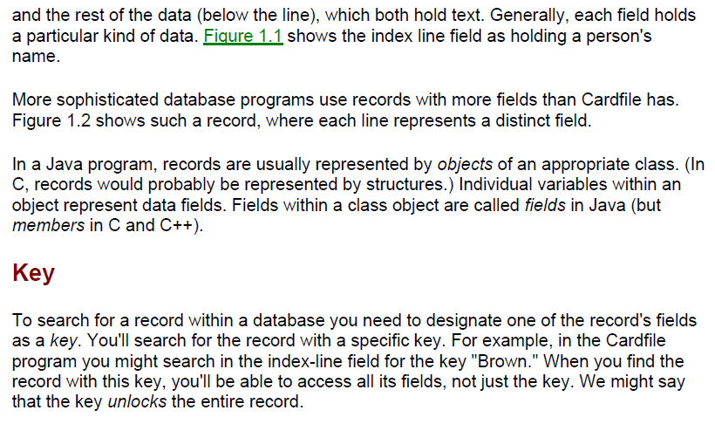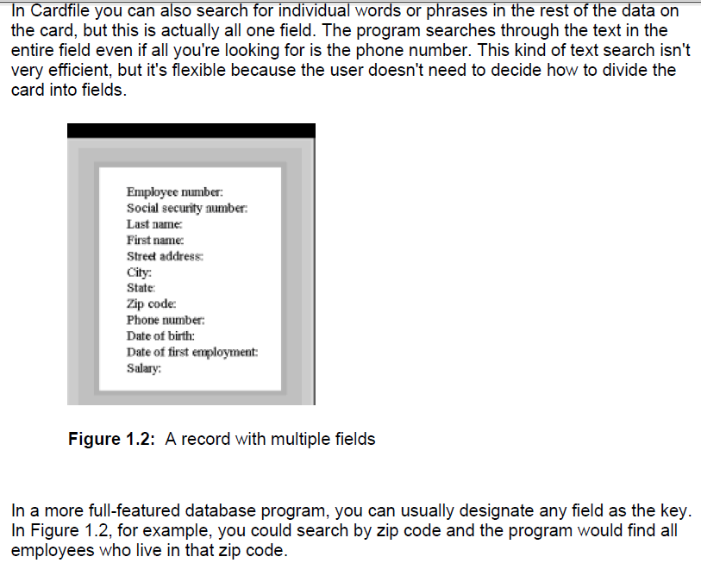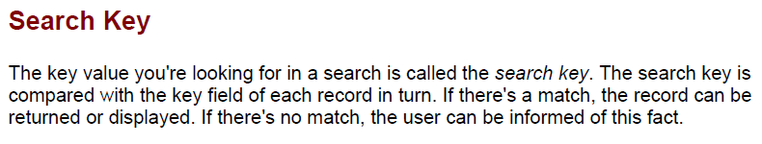
3. 结构化编程的缺点（**Problems with Procedural Languages**）：  
   不适用大型的复杂程序。（**inadequate for large and complex programs**）  
   不便于模块化。（**Crude Organizational Units**）  
   不便于把现实世界映射到计算机世界。（**Poor Modeling of the Real World**）

**Summary**

• A data structure is the organization of data in a computer's memory or in a disk file.

• The correct choice of data structure allows major improvements in program efficiency.

• Examples of data structures are arrays, stacks, and linked lists.

• An algorithm is a procedure for carrying out a particular task.

• In Java, an algorithm is usually implemented by a class method.

• Many of the data structures and algorithms described in this book are most often used

to build databases.

• Some data structures are used as programmer's tools: they help execute an algorithm.

• Other data structures model real-world situations, such as telephone lines running

between cities.

• A database is a unit of data storage comprising many similar records.

• A record often represents a real-world object, such as an employee or a car part.

• A record is divided into fields. Each field stores one characteristic of the object

described by the record.

• A key is a field in a record that's used to carry out some operation on the data. For

example, personnel records might be sorted by a LastName field.

• A database can be searched for all records whose key field has a certain value. This value is called a search key.